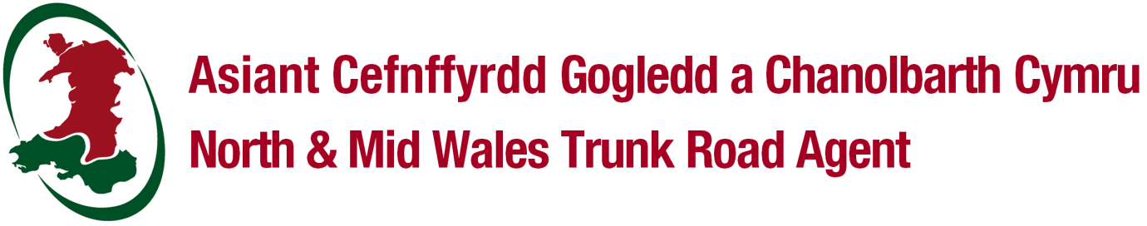
PART R1 – REGISTRATION OF WORKS
New Roads and Street Works Act 1991

Works reference

Details to be completed in capital letters and black ink.

Applicant details

(Mr/Mrs/Miss/other)
Full name
On behalf of (company)
Address
Postcode |  | E-mail
Telephone no. |  | Mobile no.

Proposed location of works

House name/no.
Street name
Village/Town |  | Postcode
Grid reference
USRN

Further information (circle as appropriate)

Has Part N been completed? |  |  |  |  |  |  | Y / N
All works on this notice complete? |  |  |  |  |  |  | Y / N | If yes, Actual Inspection Units |  |  | 1
Recipient reference number

Originator reference number

Brief description of works

Reinstatement details  (C = Carriageway; F = Footway; V=Verge) |  |  |  |  |  |  |  |  | Guarantee Start Date  (dd-mm-yy)
Item | Location | Length |  | Width | C/F/V | Deep Excavation |  |  | Interim | Permanent
1.
2.
3.
4.

Return to North and Mid Wales Trunk Road Agent
Unit 5 Llys Britannia, Parc Menai, Bangor, LL57 4BN
01286 685169 / 01286 685170: E-mail: streetworks@nmwtra.org.uk

GDPR Privacy Notice
Your personal information
The North & Mid Wales Trunk Road Agent (NMWTRA) operate as Agent on behalf of the Welsh Government (WG) for the trunk road network in North & Mid Wales.
As agent, NMWTRA will assume the role of “Data Processor” on behalf of WG who are the “Data Controller”. WG as Data Controller will be responsible for your personal information.
Why we need your information
The WG will use your information as followed:-
Data Collected | Why we need your information?
Streetworks Application | To process your streetworks applications we shall record personal data.

Justification for using your Information
The WG collects and uses your personal information because it has a legal duty or right to do so; or to perform a public interest task; or because you have given your consent. The legal term for this is called the legal basis of processing.
In this instance, the WG is using your personal information because it is undertaking a task in the public interest.
The WG will not use your information for automated decision making or profiling.
How your data will be Shared & How long will the data be retained
Your data may be shared with the following organisations and the data will be retained as detailed below.
The WG will not transfer your personal information to another country.
Data Collected | Who we will share your data with? | Retention Period
Streetworks Application | - Trunk Road Agents | 15 years

Your rights
You have legal rights, and it is important that you know what they are.
You have the right to obtain a copy of your personal data. You will be provided with copies of your personal data within the statutory period of one month (or if providing your personal data is a complex matter, this will be done as soon as is reasonable within 3 months). Your personal data will be provided to you free of charge, however, if your request is deemed manifestly unfounded or excessive, a reasonable fee will be charged. You ask to obtain your personal data by contacting the WG Data Protection Officer

You have the right to have information about you corrected.
You have the right to ask that your personal data is rectified if it is incorrect or incomplete. This will be done within 1 month, or if your request is complex, within 3 months.
The right to have personal data erased in specific circumstances:

- Where the personal data is no longer necessary in relation to the purpose for which it was originally collected/processed;
- If you withdraw your consent;
- When you object to the WG processing and there is no overriding legitimate interest for continuing the processing;
- If the personal data was unlawfully processed;
- When the personal data has to be erased in order to comply with a legal obligation; or
- When the personal data is processed in relation to the offer of information society services to a child, e.g. an app developed specifically for children.

The right to restrict processing. Where it is claimed that data is inaccurate or the right to erasure has been exercised you can require the WG to restrict processing until verification checks have been completed.
The right to data portability. Under certain circumstances, you have the right to obtain and reuse your personal data across different circumstances.
The right to object. In addition to the right to object to your information being used for direct marketing, you have the right to object to processing based on the performance of a task in the public interest/exercise of official authority (including profiling), and processing for purposes of scientific/historical research and statistics.
The right to withdraw your consent at any time if consent has been relied upon originally.
Rights in relation to automated decision making. You have the right not to be subject to decisions based solely on automated processing, including profiling, which produces legal effects on you or affects you in a significant way.
Data Protection Officer: The email address for the WG Data Protection Officer is DataProtectionOfficer@gov.wales
If you wish to complain about the way that the WG has used your personal data contact the Data Protection Officer.
If you are not satisfied with their response you also have the right to contact the Information Commissioner:

https://ico.org.uk/concerns.

Information Commissioner’s Office
Wycliffe House
Water Lane
Wilmslow
Cheshire
SK9 5AF

Telephone: 01625 545 745 or 0303 123 1113

